1.14 Plan Transfer Pricing Audit

Attribute | Description
Use case ID | BUC-TA-013
Use case Name | Plan a transfer pricing audit
Description | This use case describes how the transfer pricing audit team prepares and plans a transfer pricing audit after a case has been approved. The team performs preliminary research, determines materiality, analyzes the taxpayer’s industry, and prepares an audit plan and program for approval by the process owner.
Actors | - Primary Actors: Transfer Pricing Audit Team, Transfer Pricing Process Owner  - Secondary Actors: None
Precondition | • A transfer pricing audit case has been initiated and approved for planning  • Relevant taxpayer data and preliminary risk analysis are available
Trigger | Approval of a transfer pricing audit case by the review committee.
Normal Workflows | - The transfer pricing audit team reviews the approved audit case and available taxpayer information.  - The audit team researches and determines the materiality level, including the audit objectives, scope, context, and resources required.  - The audit team conducts research on the taxpayer’s industry, including common business practices, pricing structures, and industry risk indicators.  - The audit team determines and documents the audit sampling method to be used for examining taxpayer records and transactions.  - The transfer pricing process owner provides guidance to the audit team on the scope and priorities of the audit planning process.  - The transfer pricing audit team prepares a detailed audit plan and audit program, including the audit scope, timeline, resources, and key activities.  - The audit team submits the prepared audit plan to the transfer pricing process owner for review and approval.  - The transfer pricing process owner reviews the results of the audit preparation, including the materiality assessment, industry research, sampling approach, and proposed audit plan.  - If the plan is satisfactory, the process owner approves the audit plan.  - If required, an entry conference with the taxpayer is scheduled to formally begin the audit engagement.
Alternative Flow | AF1. Audit Plan Requires Revision  Trigger: The audit plan is incomplete or does not adequately address the identified risks(during Normal Flow Step 8).  Flow:  - The transfer pricing process owner reviews the audit plan.  - The process owner identifies gaps or weaknesses in the proposed plan.  - The audit team revises the audit plan to address the identified issues.  - The revised plan is resubmitted for approval.  - The process resumes from Step 8 of the Normal Workflow.  AF2. Additional Industry Research Required  Trigger: Industry information collected during planning is insufficient(during Normal Flow Step 6).  Flow:  - The audit team identifies gaps in the industry analysis.  - The audit team collects additional information from industry reports, government databases, or market studies.  - The audit team updates the audit plan based on the additional industry information.  - The process resumes from Step 7 of the Normal Workflow.  AF3: New Risk Identified During Planning  Trigger:  Additional transfer pricing risks are identified (during Normal Workflow Step 2 or Step 3).  Flow:  - The audit team identifies new risk indicators not captured in the initial case.  - The risks are documented with justification.  - The audit scope and objectives are updated to include the new risks.  - The audit plan is revised accordingly.  - The updated plan is submitted for review.  - The process resumes from Normal Workflow Step 7 (Submit plan for approval).
Postcondition | Success:  A comprehensive transfer pricing audit plan is approved and the audit proceeds to execution  Cancelled:  The audit plan is rejected and requires reassessment
Exceptions: | - Required taxpayer data or transfer pricing documentation is unavailable; the audit team requests the information from the taxpayer or internal sources, and planning is held until the information is received.  - The system fails to retrieve industry research data; the audit team must manually source alternative data and document the source.
Business Rules | BR-001: The audit plan must clearly define audit scope, objectives, and audit methods.  BR-002: Materiality thresholds must be documented for each transfer pricing audit.  BR-003: Industry analysis must be conducted to understand pricing practices and risk areas.
Information Requirements: | - Taxpayer financial statements.  - Industry research reports.  - Preliminary risk assessment results.  - Transfer pricing documentation (if available).  - Materiality threshold guidelines.  - Audit plan and program templates.  - Approval records and justifications for decisions.
Assumptions: | - The Transfer Pricing Audit Team has access to necessary industry databases and research tools.  - Materiality thresholds and sampling methods are predefined in organizational guidelines.  - The Process Owner has the expertise to evaluate transfer pricing audit plans effectively.
Notes and Issues | • The audit plan defines the direction and scope of the audit  • Materiality helps focus on transactions with the highest risk  • Industry analysis is essential due to differences in pricing practices  • The entry conference communicates audit objectives and expectations to the taxpayer.
Activity Diagram | 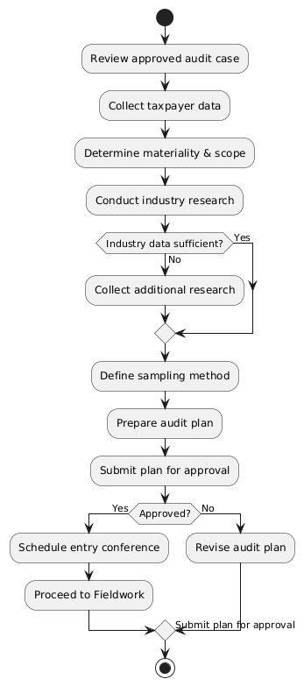

1.15 Conduct Transfer Pricing Audit Fieldwork

Attribute | Description
Use case ID | BUC-TA-014
Use case Name | Conduct Transfer Pricing Audit Fieldwork
Description | This use case describes how the transfer pricing audit team performs audit fieldwork to examine the taxpayer’s financial records and related-party transactions. The team reviews accounting systems, verifies transaction records, examines supporting documents, and collects relevant financial and pricing information to support transfer pricing analysis.
Actors | - Primary Actors: Transfer Pricing Audit Team.  - Secondary Actors : Taxpayer / Taxpayer Representative, Transfer Pricing Process Owner
Precondition | • The transfer pricing audit plan has been approved  • The audit team has access to taxpayer records and documentation
Trigger | Approval of the audit plan and commencement of fieldwork.
Normal Workflows | - The transfer pricing audit team begins audit fieldwork according to the approved audit plan.  - The audit team reviews the taxpayer’s accounting and financial reporting system to understand how related-party transactions are recorded and reported.  - The audit team identifies transactions between the taxpayer and related foreign entities that may be subject to transfer pricing examination.  - The audit team traces transaction flows and conducts an audit trail of transactions using available records such as e-invoicing data, cash register machine records, or the taxpayer’s internal accounting system.  - The audit team examines supporting documents such as invoices, contracts, shipping documents, and payment records.  - The audit team selects a representative sample of transactions for detailed examination based on the approved audit sampling method.  - The audit team verifies the selected transactions against supporting documentation and accounting records.  - The audit team reviews financial records related to the selected transactions to understand the transaction structure, pricing arrangements, and supporting cost information.  - The audit team gathers relevant financial and pricing information required for transfer pricing analysis.  - Where additional information or clarification is required, the audit team obtains approval from the transfer pricing process owner to request further information from the taxpayer.  - The audit team issues requests for additional information or documents to support factual development of the audit.  - The taxpayer provides the requested information or evidence, including documents, explanations, or access to records.  - The audit team may conduct interviews, plant tours, or site visits to better understand the taxpayer’s business operations and transaction processes.  - The audit team reviews the information obtained and incorporates it into the audit working papers.  - The audit team identifies transactions that may require detailed transfer pricing analysis.  - The audit team documents observations and organizes the collected information for the transfer pricing analysis stage.  - The transfer pricing process owner reviews the fieldwork progress and confirms that sufficient evidence has been collected for transfer pricing analysis.
Alternative Flow | AF1. No Transfer Pricing Risk Identified  Trigger: The audit examination does not reveal significant transfer pricing risk.  Flow:  - The audit team documents the findings.  - The team concludes that transfer pricing risk is minimal.  - The audit proceeds to reporting with no adjustment recommendations.
Postcondition | Success:  Audit fieldwork is completed and sufficient evidence is collected to perform transfer pricing analysis.  Cancelled:  Audit fieldwork is suspended due to insufficient records or inability to verify transactions.
Exceptions: | - The taxpayer denies access to premises for on-site verification; the audit team escalates to the Process Owner for legal enforcement or alternative procedures.  - The system fails to retrieve e-invoicing or electronic records; the audit team requests manual records from the taxpayer and documents the system failure.  - Key personnel or records are unavailable during scheduled site visits; the visit is rescheduled, and fieldwork is delayed accordingly.
Business Rules | BR-001: Transfer pricing audits must examine transactions between related entities.  BR-002: Audit sampling methods must follow established audit standards.  BR-003: Industry benchmarks must be used when evaluating pricing practices.  BR-004: Cross-border related-party transactions must receive special scrutiny.
Information Requirements: | - Taxpayer accounting records and general ledger.  - Sales and purchase transaction listings.  - Contracts and agreements with related parties.  - Invoices, payment records, and supporting transaction documents.  - Import/export and customs documentation.  - Source documents used to verify transactions.  - Fieldwork evidence (interview notes, site visit records, audit trail records).  - Information request forms and taxpayer responses.  - Working papers documenting all audit procedures performed.
Assumptions: | - The taxpayer will cooperate and provide access to records and personnel as required by law.  - The audit team has the necessary skills to evaluate accounting systems and transaction records.  - Sampling methods and materiality thresholds are predefined and applied consistently.  - The Transfer Pricing Process Owner is available to review progress and approve additional requests.
Notes & Issues | Transfer pricing risks often arise in cross-border related-party transactions  • Fieldwork focuses on identifying transactions that may shift profits  • Benchmarking data collected will support later analysis  • Sampling enables efficient review of large datasets  • Fieldwork results form the basis for transfer pricing analysis
Activity Diagram | 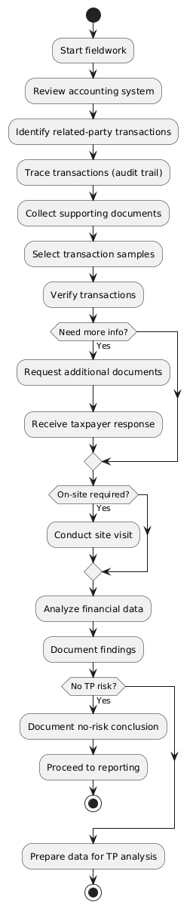

1.16 Perform Transfer Pricing Analysis
Attribute | Description
Use case ID | BUC-TA-015
Use case Name | Perform transfer pricing analysis
Description | This use case describes how the transfer pricing audit team performs detailed transfer pricing analysis using information collected during fieldwork. The team evaluates related-party transactions, selects appropriate transfer pricing methods, identifies comparable market data, and determines whether transactions comply with the arm’s-length principle.
Actors | - Primary Actors : Transfer Pricing Audit Team  - Secondary Actors : Taxpayer / Taxpayer Representative, Transfer Pricing Process Owner
Precondition | • Transfer pricing audit fieldwork has been completed  • Relevant financial records, transaction data, and comparable market information are available
Trigger | Completion of fieldwork and identification of transactions requiring transfer pricing analysis
Normal Workflows | - The transfer pricing audit team reviews the transaction data and documentation collected during audit fieldwork.  - The audit team identifies related-party transactions, particularly cross-border transactions, that require transfer pricing analysis.  - The audit team evaluates the nature of the transactions, such as transactions involving goods, services, financing arrangements, or transfers of intangible property.  - The audit team reviews comparative financial ratio analysis, including input/output ratios, profitability ratios, and cost or expense ratios, and compares these ratios with similar tax types and industry benchmarks.  - The audit team defines parameters for detailed analysis of cost and expense categories and reviews the selected cost and expense types identified for further audit examination.  - The audit team compares the taxpayer’s financial performance and transaction characteristics with relevant industry benchmarks and similar tax types to identify potential irregularities.  - The audit team assesses whether cross-border related-party transactions present potential transfer pricing risks or indicators of profit shifting.  - The audit team selects appropriate transfer pricing methods such as the Comparable Uncontrolled Price (CUP), Transactional Net Margin Method (TNMM), cost-plus, or resale price method based on transaction characteristics.  - The audit team searches for comparable transactions or comparable companies using industry benchmarking studies, international market databases, and other relevant sources.  - The audit team determines the arm’s-length price or profit range using the selected comparables and the chosen transfer pricing method.
Alternative Flow | AF1. Insufficient Comparable Market Data  Trigger: Suitable comparable transactions or companies are not readily available(during Normal Flow Step 9)  Flow  - The audit team expands the search for comparable data using international databases or additional industry sources.  - The team considers alternative transfer pricing methods that better suit the available information.  - The transfer pricing analysis continues from (Normal Flow Step 10).  AF2. Taxpayer Provides Additional Evidence  Trigger: The taxpayer provides additional transfer pricing documentation or explanations(Normal Flow Step 6 or 7)  Flow  - The taxpayer provides additional transfer pricing documentation, explanations, or supporting evidence.  - The audit team reviews and validates the submitted information.  - The audit team reassesses financial ratios, comparability, and risk indicators using the new data.  - The transfer pricing conclusions are updated where necessary.  - The analysis resumes from Normal Flow Step 8  A3. Transactions Found to be Arm’s Length  Trigger: The taxpayer’s prices fall within the acceptable arm’s-length range(During normal flow step 10).  Flow  - The audit team records that the transactions comply with transfer pricing rules.  - The audit team documents the supporting analysis.  - The audit proceeds to reporting without adjustment.
Postcondition | Success  The transfer pricing analysis is completed, and a conclusion is reached regarding whether the taxpayer’s transactions comply with the arm’s-length principle.  Cancelled  Transfer pricing analysis cannot be completed due to insufficient information or unresolved issues.
Exceptions: | - The system fails to connect to external pricing or benchmarking databases; the audit team must manually source comparable data and document the source and search methodology.  - Required industry benchmarking studies are unavailable; the audit team uses alternative data sources and documents the limitations in the analysis working papers.  - The taxpayer fails to provide requested additional evidence within the specified timeframe; the audit team proceeds with the available information and documents the absence of taxpayer cooperation.
Business Rules | BR-001: Analysis must follow applicable transfer pricing regulations  BR-002: The most appropriate method must be selected  BR-003: Arm's-length determination must be supported by comparable data.
Information Requirements: | - Transfer pricing documentation (taxpayer-prepared).  - Financial statements and transaction records.  - Comparable company or transaction data.  - Industry benchmarking studies.  - External market price data.  - Transfer pricing method selection rationale.  - Arm's-length range calculations.  - Analysis working papers and conclusions.  - Approval records and justifications for decisions.
Assumptions: | - The audit team has the technical expertise to select and apply appropriate transfer pricing methods.  - External benchmarking databases are reliable and up-to-date.  - The Transfer Pricing Process Owner has sufficient knowledge to evaluate complex transfer pricing analyses.  - Industry benchmarks and comparable data are available for the taxpayer's industry and region.
Notes & Issues | • Transfer pricing analysis ensures transactions are priced as between independent parties  • The arm’s-length principle is the core standard  • Different transactions require different methods  • Comparable data is essential for accurate evaluation  • Analysis results form the basis for audit adjustments and reporting
Activity Diagram | 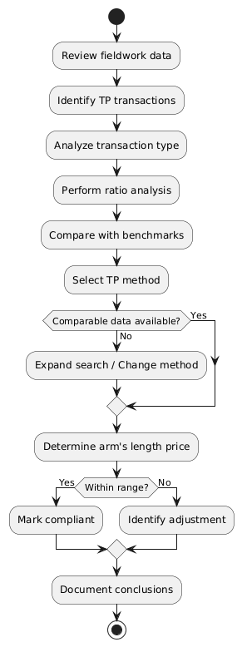

1.17 Prepare and Review Transfer Pricing Audit Report
Attribute | Description
Use case ID | BUC-TA-016
Use case Name | Prepare and review the transfer pricing audit report.
Description | This use case describes how the transfer pricing audit team prepares the audit report based on audit findings and transfer pricing analysis. The report summarizes audit procedures, findings, and conclusions regarding compliance with transfer pricing regulations.  The audit team discusses the findings with the taxpayer and submits the report for internal review and approval.  The finalized audit report is sent to the taxpayer for signoff where applicable before proceeding to audit notice issuance.
Actors | Primary Actors: Transfer Pricing Audit Team, Transfer Pricing Process Owner  Secondary Actors: Audit Team Leader, Taxpayer / Taxpayer Representative
Precondition | • Transfer pricing analysis has been completed  • Audit evidence and supporting documentation are available
Trigger | Completion of transfer pricing analysis and identification of audit conclusions
Normal Workflows | - The audit team reviews transfer pricing analysis results and audit fieldwork documentation.  - The audit team prepares a draft fact statement summarizing findings and supporting evidence.  - The audit team notifies the taxpayer of the draft fact statement for review.  - The taxpayer reviews the fact statement and submits explanations or additional supporting evidence.  - The audit team evaluates taxpayer submissions and incorporates valid clarifications.  - The audit team prepares discussion points and supporting documents for the exit conference.  - The audit team conducts the exit conference with the taxpayer to discuss audit findings and preliminary conclusions.  - Based on the discussion, the audit team drafts the audit report  - The audit team submits the draft report to the transfer pricing process owner for review and approval.  - The process owner reviews audit preparation results and the draft report to ensure completeness and accuracy.  - If needed, the audit team revises the report to reflect additional evidence or clarifications.  - The transfer pricing process owner sends the audit report to the taxpayer for review and signoff within the approved period.  - The taxpayer / representative reviews the audit report and response within the allowed period.  - Transfer Pricing Process Owner records the taxpayer’s response in the system.  - The audit report is finalized for submission to the audit team leader, ensuring proper version control and documentation
Alternative Flow | AF1. Taxpayer Disagrees with Audit Findings  Trigger: The taxpayer disputes the conclusions presented during the exit conference (during Normal Flow Step 7).  Flow  - The taxpayer presents objections, explanations, or additional supporting documentation.  - The audit team reviews and evaluates the submitted information.  - The audit team reassesses the transfer pricing analysis where necessary.  - If the new evidence is valid, the audit findings and conclusions are revised.  - The audit report is updated accordingly.  - The process resumes from Normal Flow Step 8  AF2. Additional Evidence Required  Trigger: The audit team determines that further verification is required(during Normal Flow Step 1, 5, or 10)  Flow  - The audit team collects additional documentation or clarification.  - The audit team reviews the new evidence.  - The audit report is updated accordingly.  - The process continues from Step 10 of the Normal Workflow.  AF3. Taxpayer Response Handling  Trigger: Taxpayer responds to audit report (Step 13)  Flow:  - If the taxpayer agrees, the signed report is returned.  - If the taxpayer disagrees, objection procedures are initiated.  - The process continues based on the response outcome.  AF4. No Response from Taxpayer  Trigger: No response within the approved period (after Step 13)  Flow:  - The lack of response is recorded.  - The case is escalated to tax intelligence and fraud investigation.  - Further action is initiated.  AF5. Fraud Identified During Review  Trigger: Fraud indicators detected during communication or review  Flow:  - The team leader documents fraud indicators.  - The case is referred to the investigation team.  - The “Intelligence and Tax Fraud Investigation” process is triggered.
Postcondition | Success: A complete transfer pricing audit report has been prepared, reviewed, approved, and signed or formally recorded as unsigned.  Cancelled: The audit report requires significant revision or additional investigation before approval.
Exceptions: | - The taxpayer denies receipt of the draft fact statement or audit report; the audit team sends via alternative method (registered mail, secure electronic portal) and records proof of delivery.  - The system fails to maintain version control; the audit team manually tracks versions and documents all changes until system functionality is restored.  - Key audit team members are unavailable during the exit conference; the conference is rescheduled, and the taxpayer is notified.
Business Rules | BR-001:: Every transfer pricing audit must result in a documented audit report  BR-002: Audit findings must be supported by evidence and analysis  BR-003: The taxpayer must be given the opportunity to review finding  BR-004:The final audit report must be sent to the taxpayer for signoff before notice issuance
Information Requirements: | - Finalized transfer pricing analysis results.  - Audit fieldwork documentation and evidence.  - Taxpayer responses and supporting evidence.  - Draft fact statement.  - Exit conference discussion points and minutes.  - Draft and revised audit report versions.  - Taxpayer signoff or objection documentation.  - Approval records and justifications for decisions.  - Escalation records for fraud or non-response cases.
Assumptions: | - The taxpayer will act in good faith and respond within the allowed period.  - The Transfer Pricing Audit Team has the necessary skills to prepare clear and defensible audit reports.  - The Transfer Pricing Process Owner has the expertise to evaluate audit reports for completeness and accuracy.  - The taxpayer has access to the audit report and sufficient time to review and respond.
Notes & Issues | • The audit report consolidates fieldwork evidence and analytical conclusions.  • The exit conference ensures transparency and taxpayer engagement.  • The finalized report serves as the basis for audit communication and assessment
Activity Diagram | 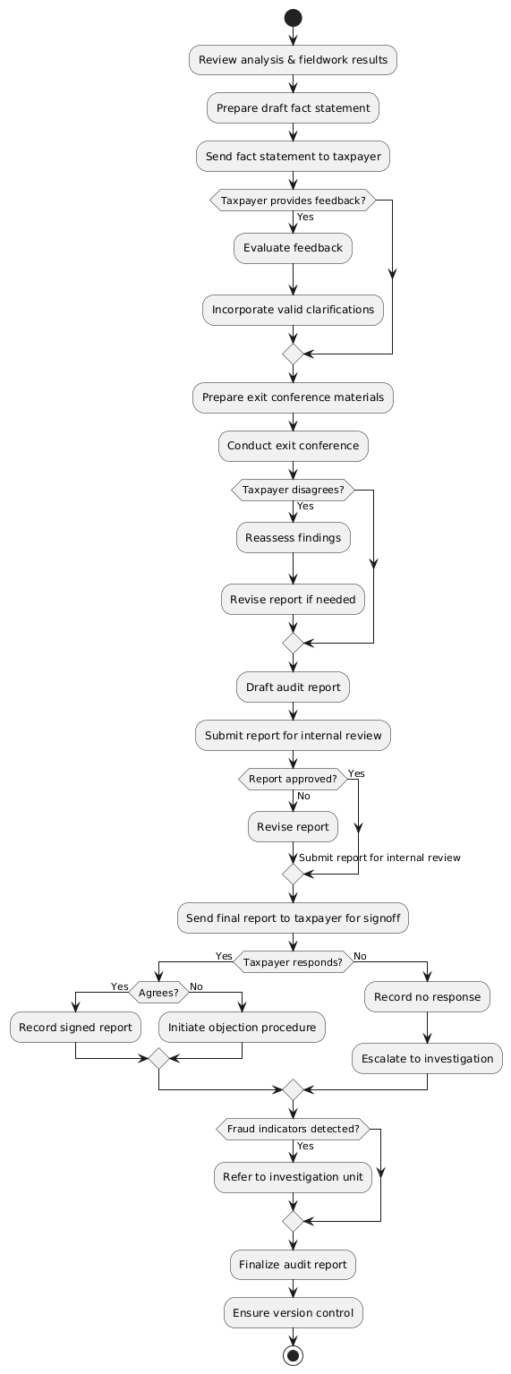

1.18 Issue Audit Notices and Manage Audit Communication
Attribute | Description
Use case ID | BUC-TA-017
Use case Name | Issue Audit Notices and Manage Audit Communication
Description | This use case describes how tax authorities formally notify taxpayers about transfer pricing audit activities and communicate the outcome of the audit. The system generates audit notices using approved formats, manages communication records, and tracks responses and delivery status of notices.
Actors | - Primary Actor : Transfer Pricing Audit Team  - Secondary Actors: Transfer Pricing Process Owner, Taxpayer / Taxpayer Representative, MoR Administrative Staff
Precondition | • The transfer pricing audit report has been reviewed and approved  • Audit activities require formal communication with the taxpayer
Trigger | Completion of audit report finalization and requirement to formally notify the taxpayer through audit notice issuance.
Normal Workflows | - The transfer pricing audit team prepares an audit notice using approved formats and includes relevant taxpayer details.  - The transfer pricing audit team ensures a unique reference number is assigned to the notice for tracking.  - The transfer pricing process owner reviews and approves the audit notice.  - The transfer pricing audit team sends the approved notice to the taxpayer through appropriate communication channels and ensures the taxpayer is notified.  - Administrative staff prints notices individually or in bulk when physical delivery is required and arranges dispatch.  - The transfer pricing audit team records the issued notice in the taxpayer’s audit file and updates communication history (date, status, responsible outcome).  - The Transfer Pricing Audit Team maintains a list of taxpayers under audit and tracks all issued notices.
Alternative Flow | AF1. Undelivered Notice  Trigger: The notice is returned as undelivered( During Normal flow step 4).  Flow  - Administrative staff record the undelivered notice.  - An action plan is prepared to contact the taxpayer through alternative means.  - The responsible team attempts to re-establish communication with the taxpayer.  AF2. Email Communication Requested  Trigger: The taxpayer has requested electronic communication(During Normal flow step 4)  Flow  - The audit team verifies the taxpayer’s preferred communication channel.  - The notice is sent via secure electronic communication (email or portal).  - Delivery confirmation (read receipt or system acknowledgment) is captured.  - The communication is recorded in the audit communication log.  - The process continues to Normal Flow Step 6 (Record notice and update history).
Postcondition | Success  Audit notices and communications are delivered and recorded in the audit history.  Cancelled:  Communication with the taxpayer cannot be established and requires further administrative action.
Exceptions: | - The system fails to generate the notice within performance thresholds; the audit team manually generates the notice using templates and records the system issue for IT resolution.  - The secure electronic communication channel is unavailable; the audit team uses an alternative approved channel (physical delivery, registered mail) and documents the reason.  - The taxpayer's contact information is outdated or incorrect; the audit team searches internal systems or external sources for updated information before attempting delivery.
Business Rules | BR-001: All audit notices must follow approved MoR formats.  BR-002: Audit notices must be issued within a configurable period
Information Requirements: | - Approved audit notice templates (various types: commencement, information request, preliminary findings, final assessment, etc.).  - Taxpayer contact information (address, email, phone, authorized representative details).  - Issued audit notices and reference records.  - Delivery confirmation and tracking information.  - Taxpayer responses and clarification requests.  - Communication history log (date, type, status, responsible officer, outcome).  - List of taxpayers under audit with notice tracking status.
Assumptions: | - Approved notice templates are maintained and up-to-date in the system.  - The taxpayer's contact information is accurate and current in the tax administration database.  - The Transfer Pricing Process Owner is available to review and approve notices in a timely manner.  - Electronic communication channels are secure and provide delivery confirmation.
Notes & Issues | - Timely communication is critical for taxpayer compliance and response handling.  - Audit notices may include: audit commencement notices, information requests, preliminary findings, final assessment notices, and extension letters.  - Physical delivery may be required for legal validity in certain jurisdictions or for specific notice types.  - All communications should be conducted in the taxpayer's preferred language where feasible.  - This use case ensures that taxpayer rights to notice and response are respected throughout the audit process.
Activity Diagram | 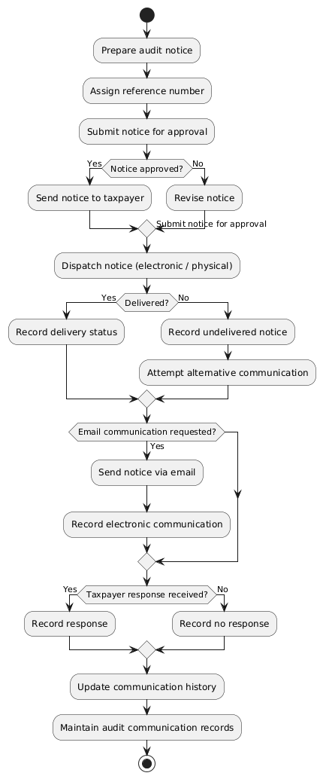

1.19 Issue Assessment Notice and Conclude Transfer Pricing Audit
Attribute | Description
Use case ID | BUC-TA-018
Use case Name | Issue Assessment Notice and Conclude Transfer Pricing Audit
Description | This use case describes how the tax authority issues the official assessment notice to the taxpayer, allows acceptance or objection within a defined period, and concludes the transfer pricing audit. It also supports escalation to investigation and generation of management reports.
Actors | - Primary Actors : Transfer Pricing Audit Process Owner, Authorized Tax Official  - Secondary Actors : Taxpayer / Tax Agent, Audit Staff and Analysts
Precondition | The transfer pricing audit report has been finalized and approved.  The audit report has been signed by the taxpayer.
Trigger | Approval of the final transfer pricing audit report
Normal Workflow | - The authorized tax official prepares the assessment notice based on approved audit findings, including principal, penalties, and interest.  - The assessment notice is reviewed and approved before issuance.  - The approved assessment notice is issued to the taxpayer or tax agent through appropriate channels.  - The taxpayer or tax agent receives and reviews the notice.  - The taxpayer confirms receipt via acknowledgment or signature.  - The taxpayer submits a response within the defined period.  - The process owner records the taxpayer’s response in the audit file, including date, status, and outcome.  - The audit case proceeds based on the taxpayer’s response.  - Audit staff and analysts use audit tools to analyze records, link e-invoicing systems and third-party data, and access remote ledgers where applicable.  - Audit staff generate management reports, including assessment amounts, penalties, appeals, audit yield, productivity, and other key performance indicators.  - The audit case is finalized and closed based on the outcome of the assessment and reporting.
Alternative Flow | AF1: Taxpayer Accepts Assessment  Trigger:  The taxpayer accepts the assessment (during Normal Workflow Step 6: Taxpayer response).  Flow:  - The taxpayer reviews the assessment notice and formally accepts the findings.  - Acceptance is recorded in the audit system.  - The audit completion process is initiated.  - Any required payment or compliance steps are triggered.  - The audit case is finalized and closed successfully.  - The process continues to Normal Workflow Step 10 (Case finalization and closure).  AF2: Taxpayer Raises Objection  Trigger:  The taxpayer disagrees with the assessment (during Normal Workflow Step 6).  Flow:  - The taxpayer submits a formal objection within the legally defined timeframe.  - The objection is recorded in the audit system.  - Supporting documentation is reviewed for completeness.  - The case is forwarded to the objection/appeal process according to tax procedures.  - The process continues from Normal Workflow Step 8 (Proceed based on response).  AF3: No Response from Taxpayer  Trigger:  No response is received within the defined period (after Normal Workflow Step 6).  Flow:  - The system detects that the response deadline has passed.  - The lack of response is recorded in the audit file.  - The assessment is treated as enforceable according to tax regulations (e.g., deemed acceptance or default).  - The case may be escalated to enforcement or investigation units if required.  - The audit proceeds to Normal Workflow Step 10 (Finalization and closure).  AF4: Potential Fraud Identified  Trigger:  Fraud indicators are identified (during Normal Workflow Step 8 or Step 9: Case progression or analysis).  Flow:  - The Transfer Pricing Process Owner documents suspected fraud indicators.  - Supporting evidence is compiled and recorded.  - The case is referred to the tax intelligence and fraud investigation unit.  - The Tax Fraud Investigation process is initiated.  - The audit process may be suspended or continued in parallel depending on severity.
Postcondition | Success:  Assessment notice issued, taxpayer response recorded, audit case concluded for the issued assessment notice if accepted, and reports generated.  Escalation:  The case proceeds to objection review, appeal procedures, or fraud investigation.
Exceptions: | - The system fails to generate the assessment notice within performance thresholds; the Authorized Tax Official manually prepares the notice using templates and records the system issue for IT resolution.  - The taxpayer cannot be reached for delivery of the assessment notice; alternative delivery methods are attempted, and if unsuccessful, the notice is considered constructively delivered as per legal provisions.  - The management reporting system is unavailable; audit staff manually compile key performance indicators from available records and document the system unavailability.
Business Rules | BR-001: Assessment notices must only be issued after approval of the audit report.  BR-002: Taxpayers must be allowed to accept or object to the audit findings.  BR-003: Objections must be submitted within the legally defined period.
Information Requirements | - Final transfer pricing audit report.  - Approved audit notice templates (assessment notice format).  - Taxpayer contact information and authorized representative details.  - Taxpayer response (acceptance, objection, or payment plan request).  - Assessment calculation details (principal, penalties, interest).  - Delivery confirmation and acknowledgment records.  - Objection and appeal documentation (if applicable).  - Fraud referral documentation (if applicable).  - Management reports (assessment amounts, penalties, appeals, audit yield, productivity, KPIs).  - Audit case closure checklist.
Assumptions: | - The taxpayer has received the final audit report and had the opportunity to review findings before assessment notice issuance.  - The Authorized Tax Official has the legal authority to issue assessment notices.  - The Transfer Pricing Process Owner is available to review and approve assessment notices.  - The objection and appeal process is defined and available for cases where the taxpayer disagrees.  - Management reporting requirements and KPIs are predefined by tax administration leadership.
Notes & Issues | •The taxpayer must be formally informed of the audit results before the case is concluded.  • The assessment notice represents the official determination of tax adjustments resulting from the transfer pricing audit.  • The taxpayer retains the right to object to the assessment according to applicable tax laws.
Activity Diagram | 